**ACCOR HOTELS**

Accor hotels website was confusing when first entered. The visuals on the home page was tiring for the eyes making it difficult to stay at on the page for too long. However, the site does provide easy to understand booking forms with icons as extra guidance, with extra features initially hidden but still made available for more advanced users. Upon further analysis, it was found that the home page that was shown on the device (surface pro) was the mobile version of the site and the desktop version can be accessed by clicking the link embedded in the logo.

Pros

* Simple booking form with extra features still available for advanced users (Figure 3)
* Simple and easy to understand hotel listing page
* Filters for different rooms
* Modifying selections after submitting form
* Mobile version available

Cons

* Confusing first page for laptop users with smaller screen size (Figure 1)
* Visually tiring background (Figure 2)
* Red outline is confusing
* Pressing the logo goes to another home page (Figure 4)

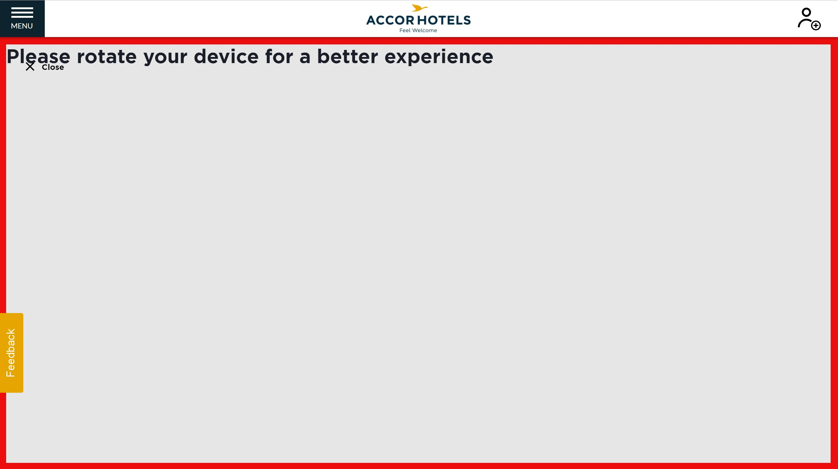

**Figure 1**. Initial page when website loaded with surface pro

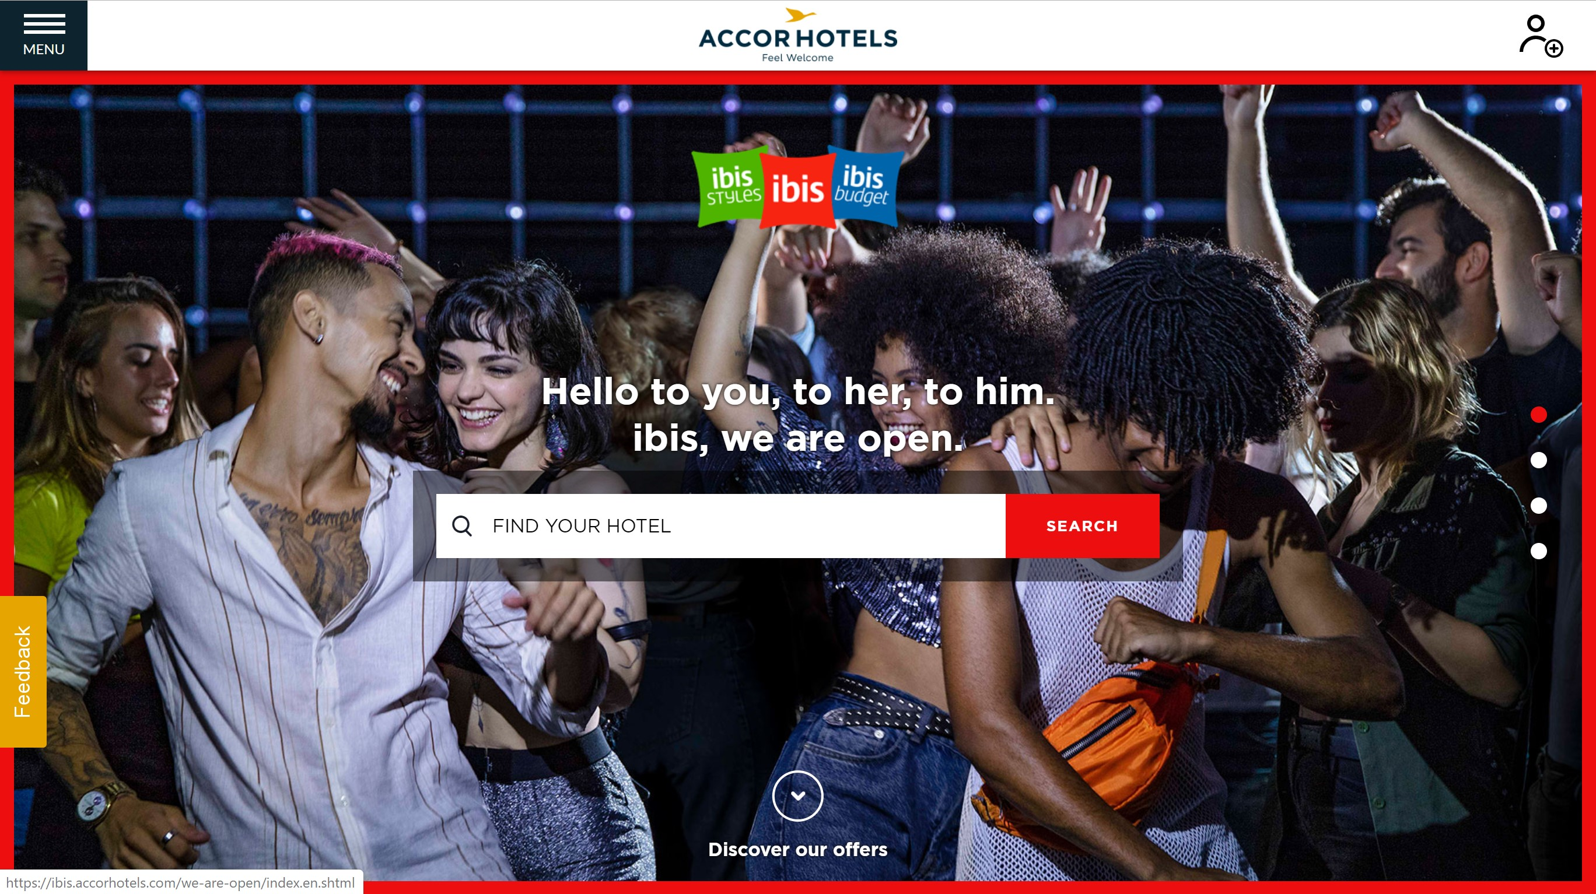

**Figure 2**. Messy background

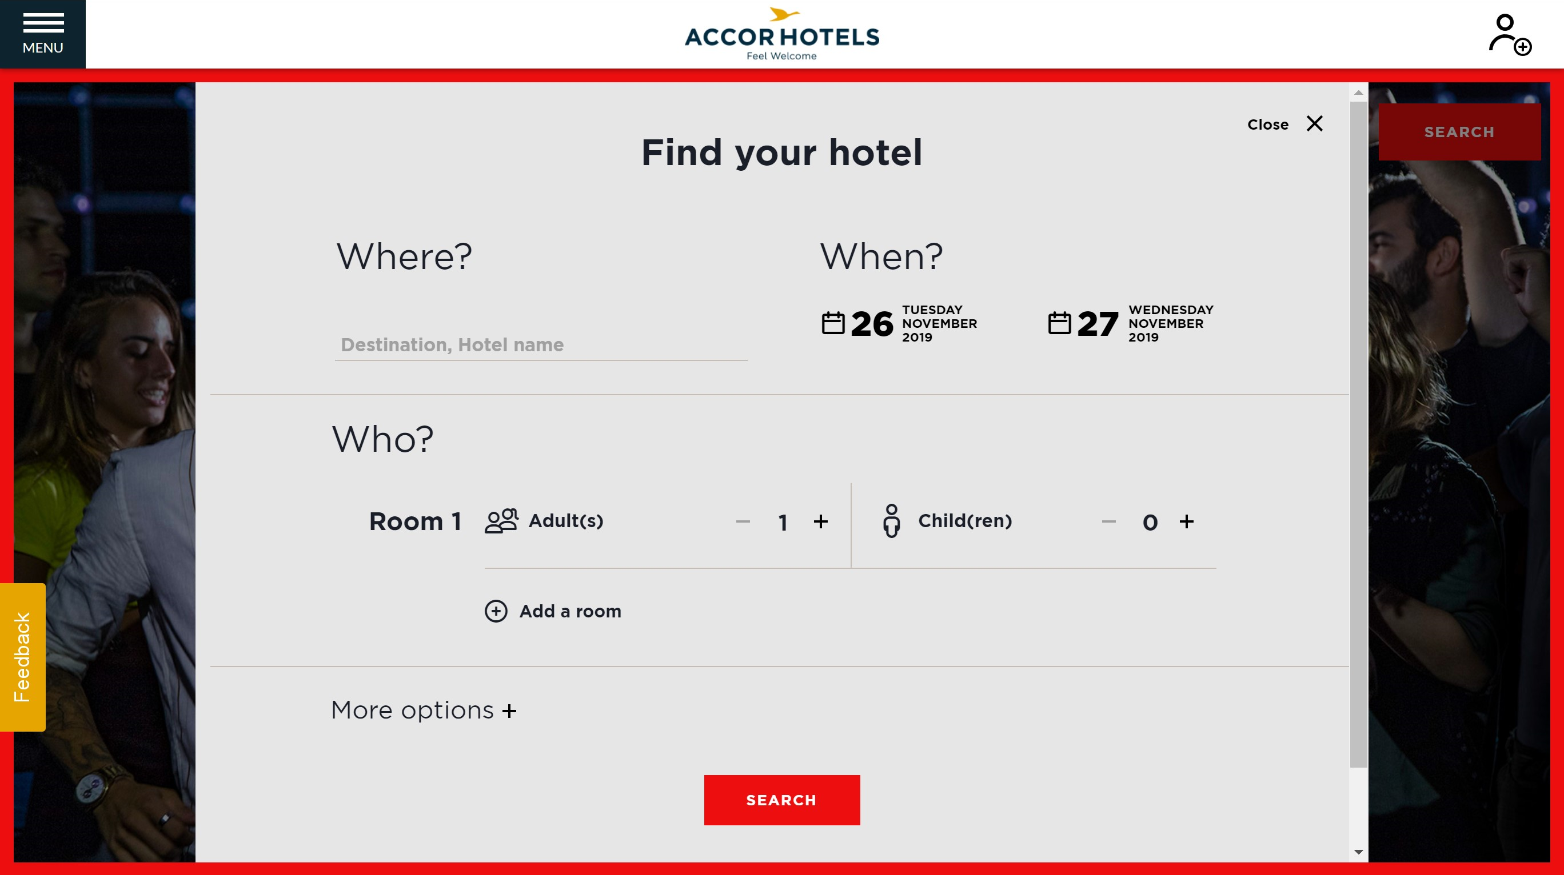

**Figure 3.** Simple booking form

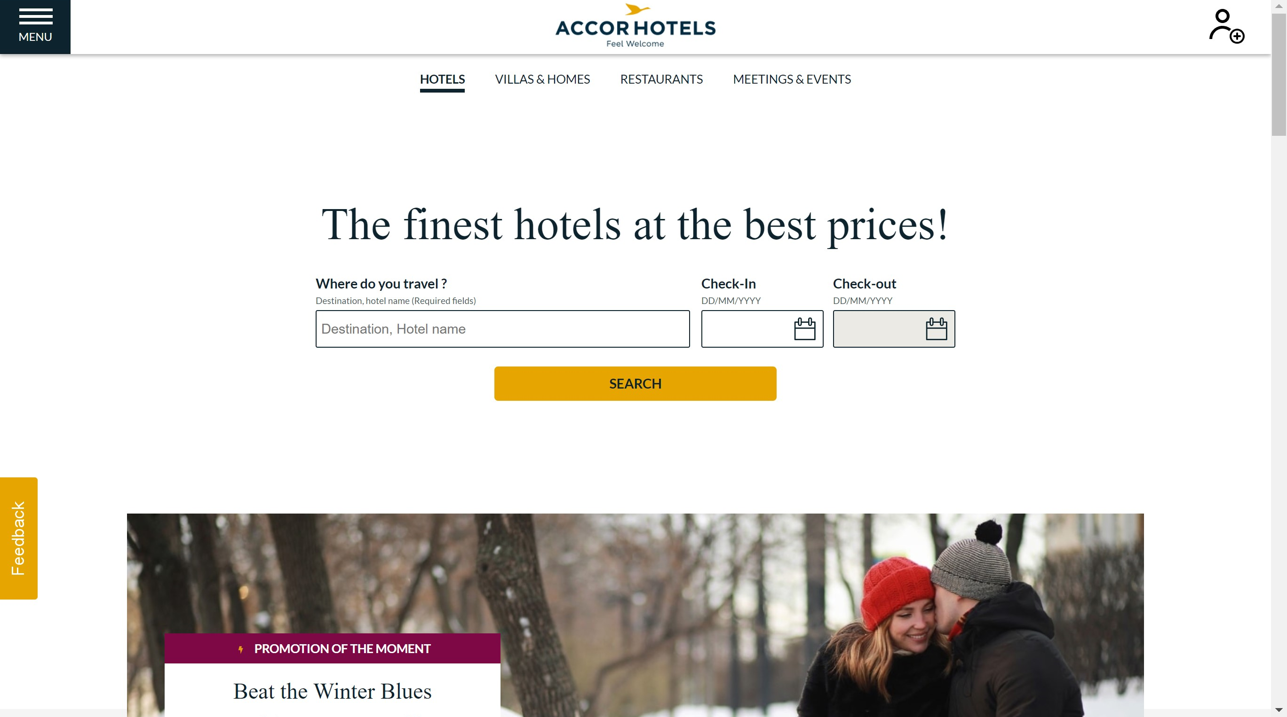

**Figure 4.** Another home page

**Travelodge**

The Travelodge site focuses on simplicity, making it a simple website to navigate and locate required features. The website uses conventional website design with menu bar at the top and footer at the bottom. One potential problem for the site is that the booking form is not as clear as other sites which might cause a slight delay in users that are focusing on quick bookings

Pros

* Simple and generic menu bar
* Simple background and design
* Simple hotel listings
* Maps to show hotel locations

Cons

* Booking form is smaller making it harder to spot

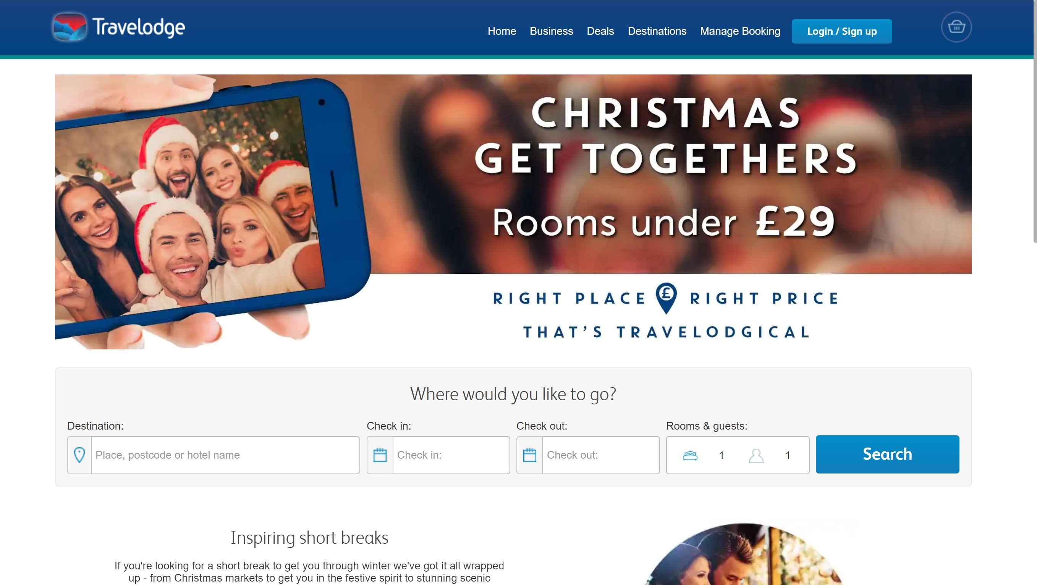

**Figure 5.** Home page for Travelodge

**Holiday Inn**

Holiday Inn also focus on simplicity in design however it also provided several features that might improve user experience for newer users such as having the phone number and language settings right on the top of the page. The hotel listing page clearly highlights the user’s current selections and allows change after form submission. However, there isn’t any clear way of navigating back to the home page after going to the hotel listing page.

Pros

* Phone number at the top for easy troubleshooting
* Language settings on the top of the page
* Simple website design
* More settings when booking form is pressed
* Clear hotel listing

Cons

* Slightly unclear booking form
* Video at the top of the page
* No clear way of returning to home page from hotel listings

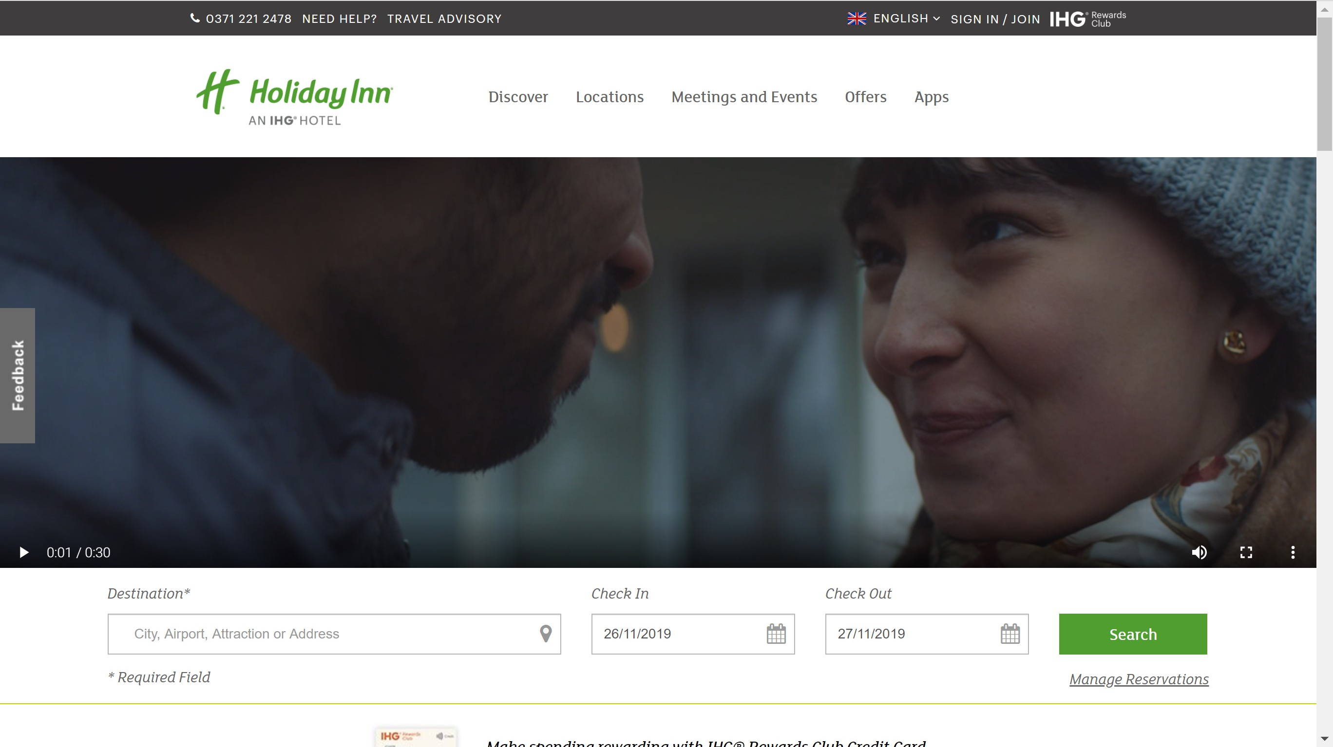

**Figure 6.** Home page for holiday inn

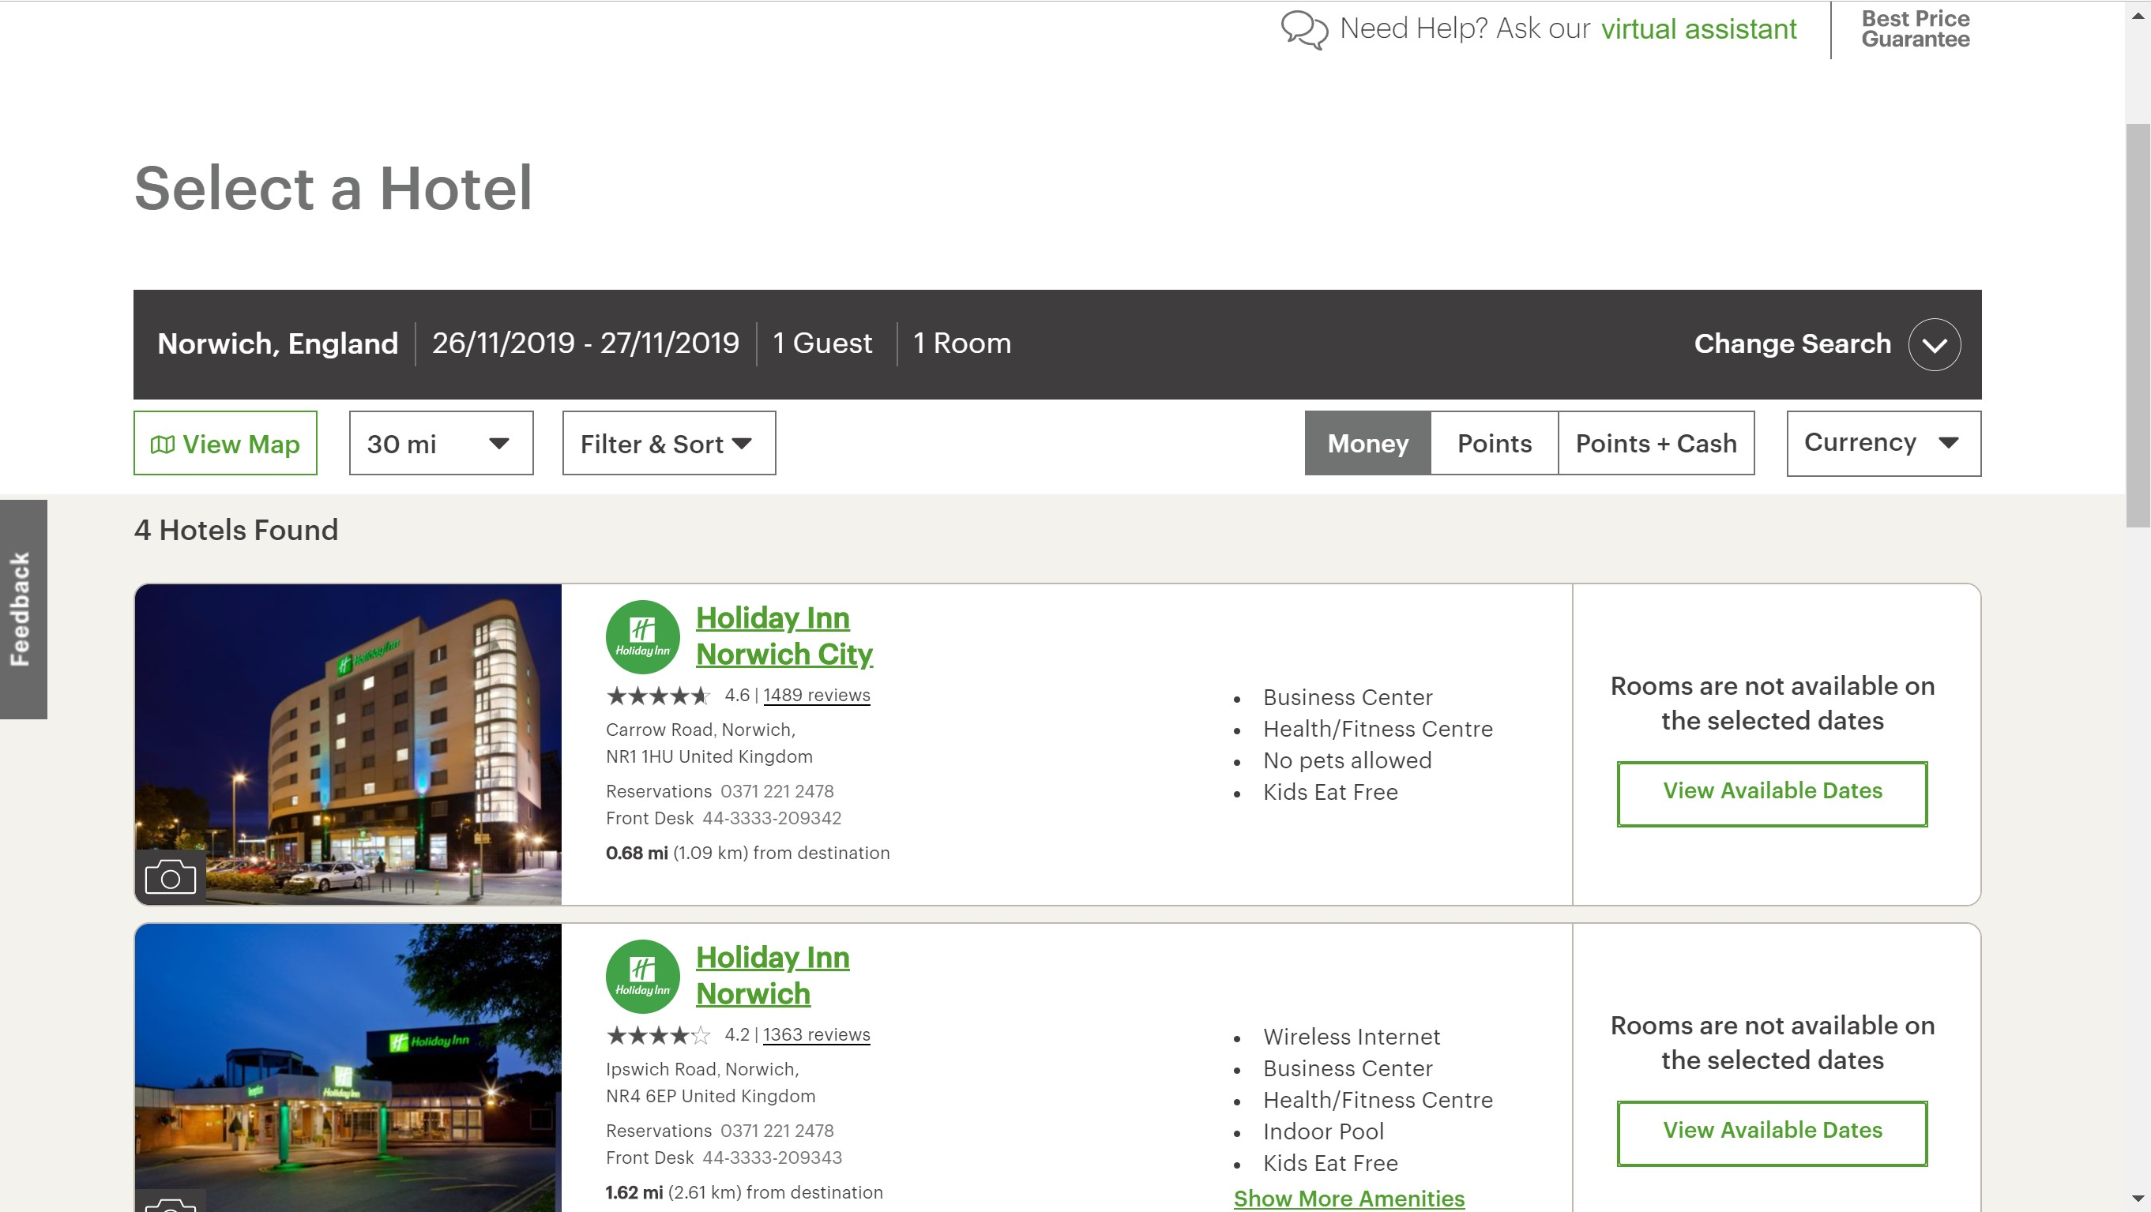

**Figure 7.** Hotel listing page

**Citizen M**

Citizen M’s site provides an extremely clear booking form which would speed up most of the user activities as most intend to use the website for hotel booking. The colours used on the site might be visually tiring however it’s part of the organisations **brand image**. The multimedia on the site might be a potential problem for users with weaker internet connection but aside from that the site is clear of it’s intention and brand image.

Pros

* Clear booking form
* All dropdown list to prevent errors
* Structured to site
* Sticky header

Cons

* Video on screen
* Multiple media on screen

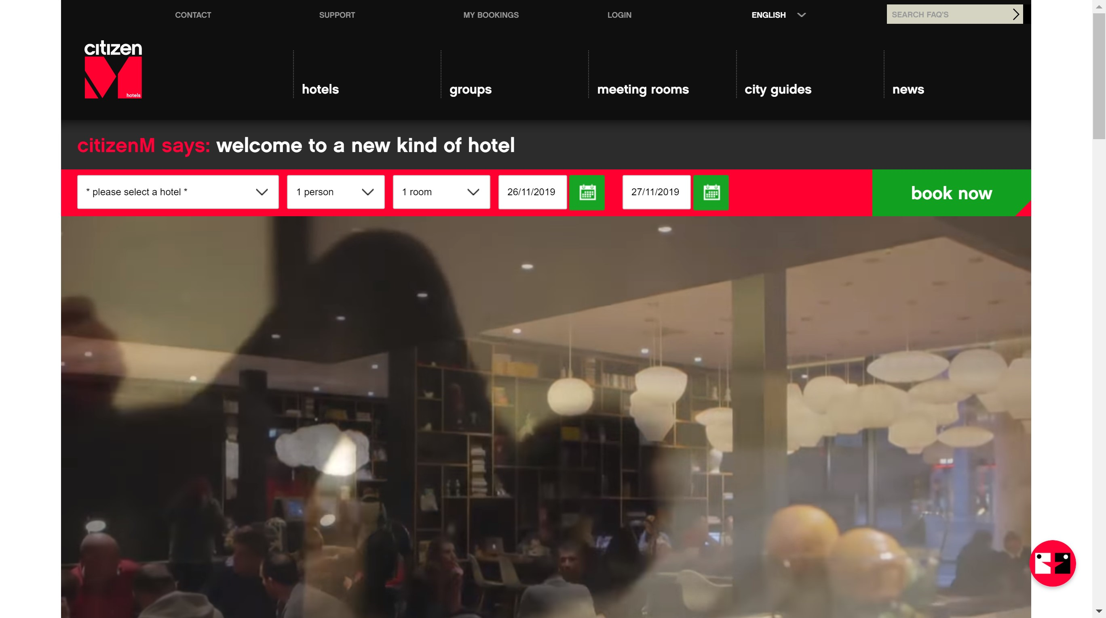

**Figure 8.** Home page for CitizenM